Objectif: Can I present my opinions about School subjects?
Utilisez les verbes correctement
Use verbs correctly to start my sentences

Utilisez les verbes en formes positifs et negatives.
Use both positive and negative forms of the verbs

Ecrivez les phrases plus longues avec les connectives
Write longer phrases using connectives

Prononcez les phrases correctement
Pronounciation and spelling is good and readily understandable

What could be done to improve this presentation?

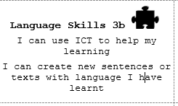
Stick your QR Code here
1
I would rate my project against the criteria above at: Literacy:
Oracy:

Because:

4
Mon Projet: Date:

